EYFS:
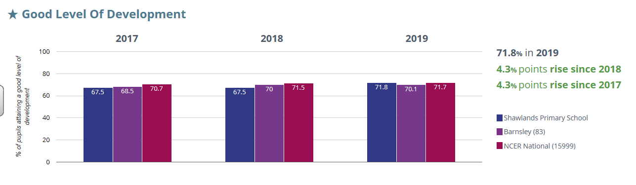

PHONICS (YEAR 1):
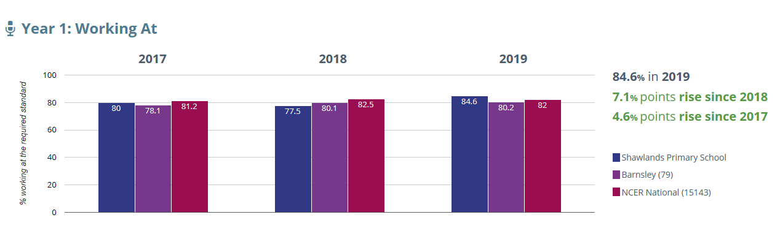

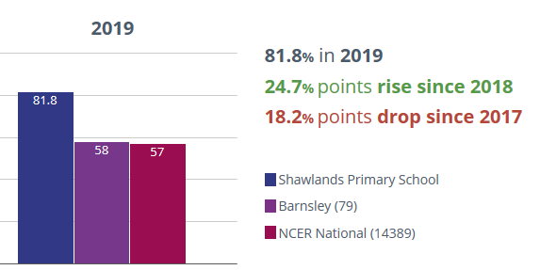
PHONICS (YEAR 2):

KEY STAGE ONE:
 |  | 2018 Sch | 2018 Nat | 2019
READING | EXS | 78 | 75 | 70 (77)
 | GD | 18 | 26 | 18 (26)
WRITING | EXS | 70 | 70 | 70 (72)
 | GD | 8 | 16 | 13 (18)
MATHS | EXS | 65 | 76 | 85 (82)
 | GD | 10 | 22 | 25 (23)
COMBINED | EXS | 60 | 65 | 60 (67)
 | GD | 5 | 12 | 15 (18)

KEY STAGE TWO:
 | 2018 Sch | 2019 Nat | 2019 sch
READING | 73 | 73 | 74 (77) | Progress
 | 23 | 28 (‘18) | 19 (32) | 1.08
WRITING | 73 | 78 | 77 (72) | Progress
 | 17 | 20 (‘18) | 26 (26) | 1.66
MATHS | 70 | 79 | 90 (81) | Progress
 | 33 | 24 (‘18) | 38 (26) | 5.2
COMBINED | 57 | 65 | 74 (65)
 | 17 | 10 (‘18) | 12 (16)
GPS | 80 | 78 | 77 (78)
 | 37 | 34 (‘18) | 38 (42)

